

**Lab # 04**

**Student Name: Ali Hassan**

**Roll Number: BIT-23F-017**

**Section: A**

**Subject: Artificial Intelligence**

**Department: BS Information Technology**

**Objective: To get Familiar with Logical operators and Conditional Structure and Loops**

The objective of this lab manual is to familiarize students with logical types and functions in Python.

**1. Introduction to Logical Types:**

Logical types in Python represent truth values. The two logical types in Python are `True` and `False`, which are instances of the `bool` class.

1. **Boolean Operators**:
   1. And: Returns true if both operands are true.
   2. OR: Returns true if either operand is true.
   3. Nott: Returns the opposite Boolean value of the operand.

**Boolean Operations Example:**

x = True

y = False

print(x and y) # Output: False

print(x or y ) # Output: True

print(not x) # Output: False

1. **Conditional Statements:**

**if, ELIF, AND ELSE STATEMENTS:**

Conditional statements allow us to execute different blocks of code based on certain conditions.

Conditional Statements Example:

age = 20

if age < 18:

print("You are a minor.")

elif age >= 18 and age < 65:

print("You are an adult.")

else:

print("You are a senior citizen.")

**Assignments**

* Write a Python function to check if a number is even or odd.
* Write a Python function to find the maximum of three numbers.
* Make starred shapes using Loops
* **Write a Python function to check if a number is even or odd.**

**Code:**

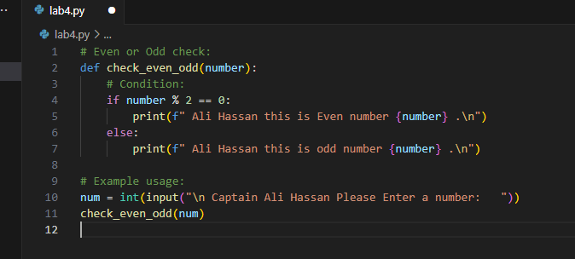

**Out Put: Even**

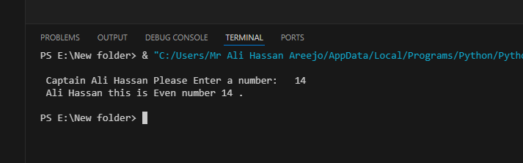

**Output: Odd**

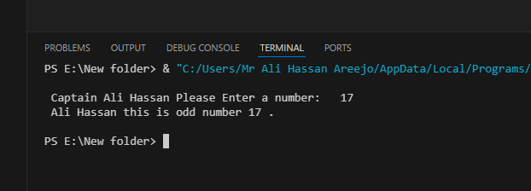

* **Write a Python function to find the maximum of three numbers.**

**Code:**

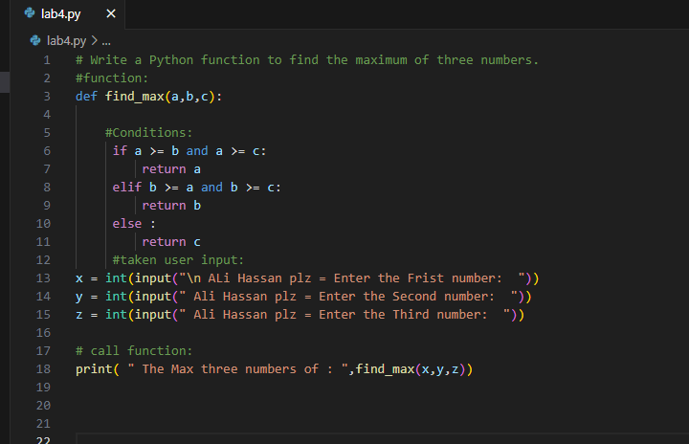

**Output:**

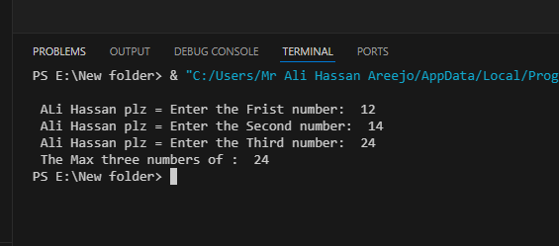

* **Make starred shapes using Loops:**

1. **Right-Angled Triangle:**

**Code:**

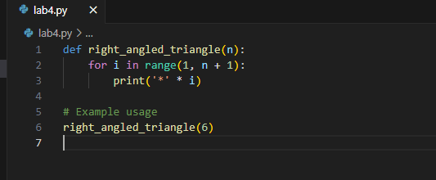

**output:**

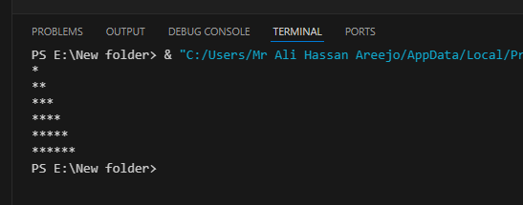

**2. Pyramid**

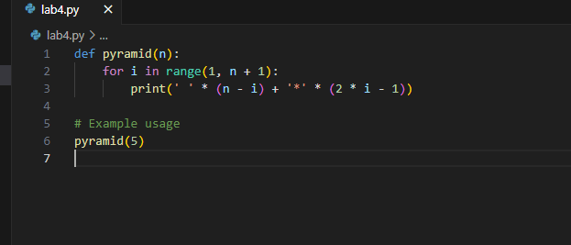

**output:**

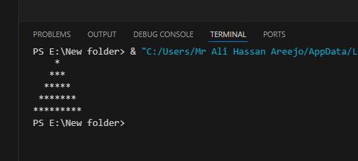

**3. Diamond Shape**

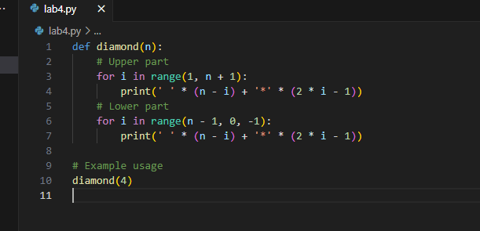

**Output:**

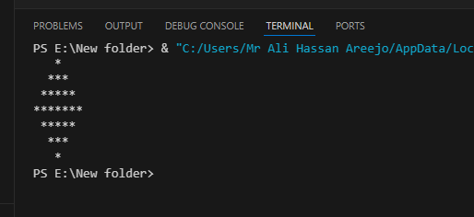

**4.Inverted Pyramid:**

**Code:**

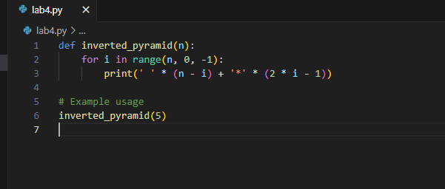**output:**

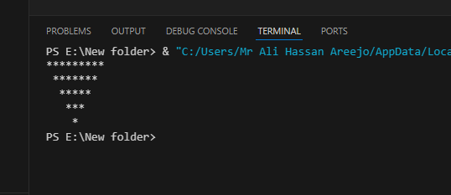

**5. Inverted Right-Angled Triangle:**

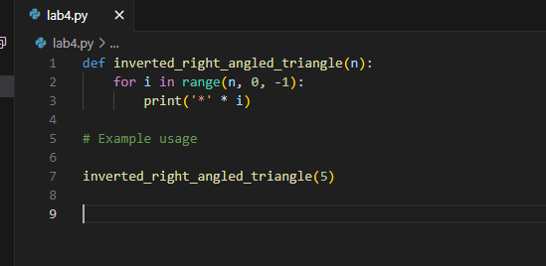

**Output:**

